**What is Servlet? Servlet API? Servlet Lifecycle?**

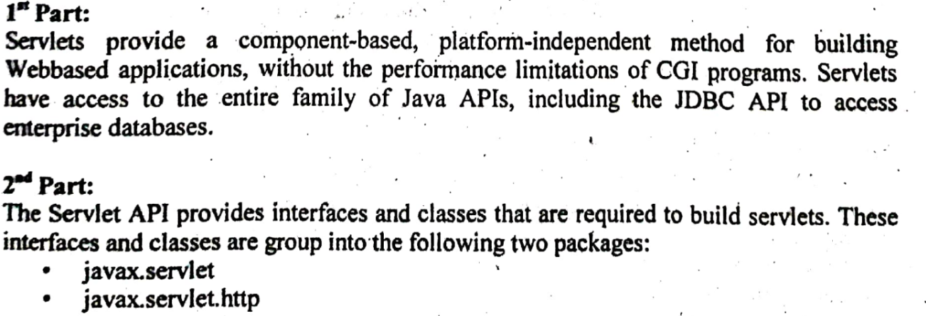

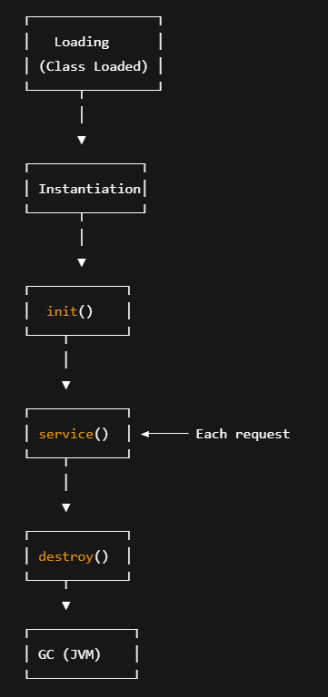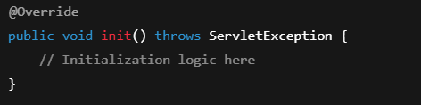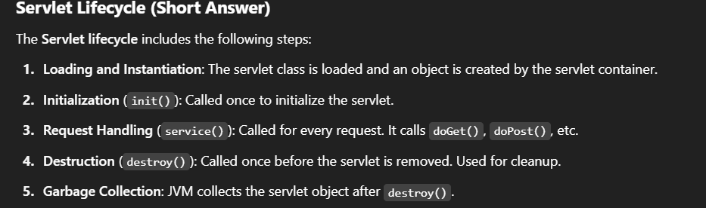

**Intranet vs Internet vs Extranet?**

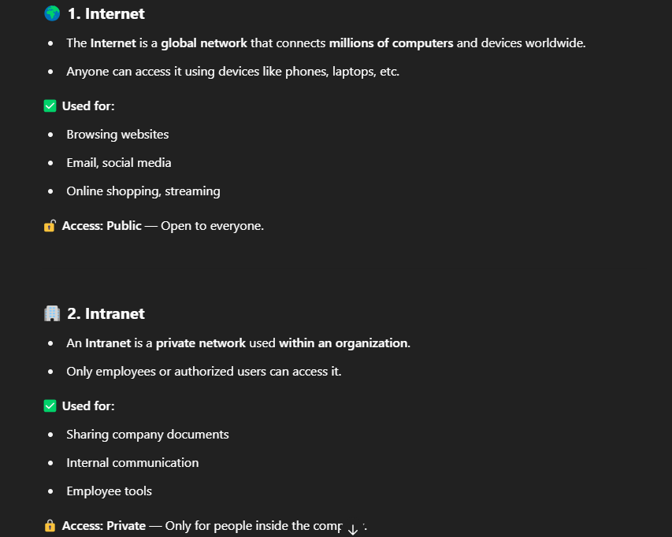

**What Does Stateless Mean in HTTP?**

* Every HTTP request is **completely independent**.
* The server does **not remember** anything about the client's previous requests.
* There is **no built-in mechanism** in HTTP to store user session information across requests.

**What is a DSN (Data Source Name)?**

**DSN** stands for **Data Source Name**. It's a data structure used by ODBC (**Open Database Connectivity**) to **define a connection to a database**. A DSN contains:

* The **name** of the data source
* The **driver** to use (e.g., SQL Server, MySQL)
* The **server** name or address
* The **database** name
* Optional: Username and password

It saves you from having to repeatedly type connection details in your apps or scripts.

**Client server communication?**

The client-server communication channel is full-duplex and typically implemented over a reliable, ordered byte stream like TCP. During the initial handshake, the client is authenticated, and communication settings (e.g., endianness) are negotiated. Clients send requests—often in batches—to the server, which processes them in order per client but multiplexes across clients. Each request has a sequence number for tracking. Responses (or replies) use these sequence numbers so clients can match replies to requests. Errors also include sequence numbers for easier debugging. The protocol is asynchronous, so replies and errors may arrive after the client has sent many other requests.

**What is the meaning of the term 'Hypertext Transfer Protocol' in World Wide Web environment?**

Hypertext Transfer Protocol (HTTP) is the foundation of communication on the World Wide Web. It is a protocol (a set of rules) used by web browsers and web servers to request and transfer data, such as web pages, images, and videos.

In simple terms, HTTP defines how messages are formatted and transmitted, and how web servers and browsers should respond to various commands. For example, when you enter a website URL in your browser, HTTP is used to send a request to the server, which then sends back the website content.

Key points:

* HTTP is a stateless protocol (each request is independent).
* It uses requests (like GET, POST) and responses to exchange data.
* It runs over TCP/IP and usually operates on port 80 (HTTPS, the secure version, uses port 443).

**SMTP Email Delivery System: Stages**

Stage 1: Composition

* User writes an email using a Mail User Agent (MUA) like Outlook, Gmail, Thunderbird, etc.
* The message includes the recipient's address, subject, and body.

Stage 2: Submission

* The email is submitted to the Mail Submission Agent (MSA) (often the sender's SMTP server).
* MSA verifies authentication and prepares the email for transmission.

Stage 3: Delivery by Mail Transfer Agent (MTA)

* The email is passed to the Mail Transfer Agent (MTA).
* The MTA looks up the recipient's domain using DNS and finds the MX record (Mail Exchange record).
* Then, the MTA sends the email to the recipient's MTA using SMTP.

Stage 4: Receipt by Mail Delivery Agent (MDA)

* The recipient’s MTA hands the email to the Mail Delivery Agent (MDA).
* MDA stores the email in the recipient's mailbox (e.g., in a mail server using IMAP or POP3).

Stage 5: Access by Recipient

* The recipient retrieves the email using an email client (MUA) through IMAP or POP3.

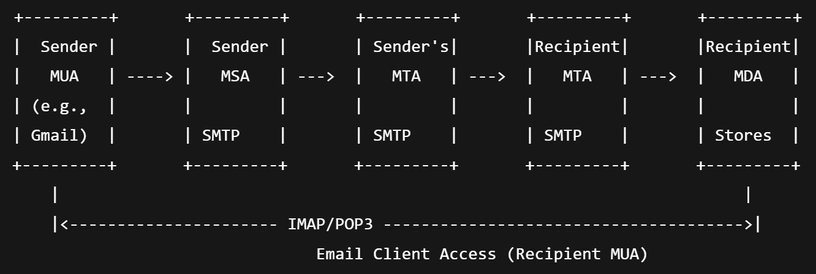

**Three-way Handshake**

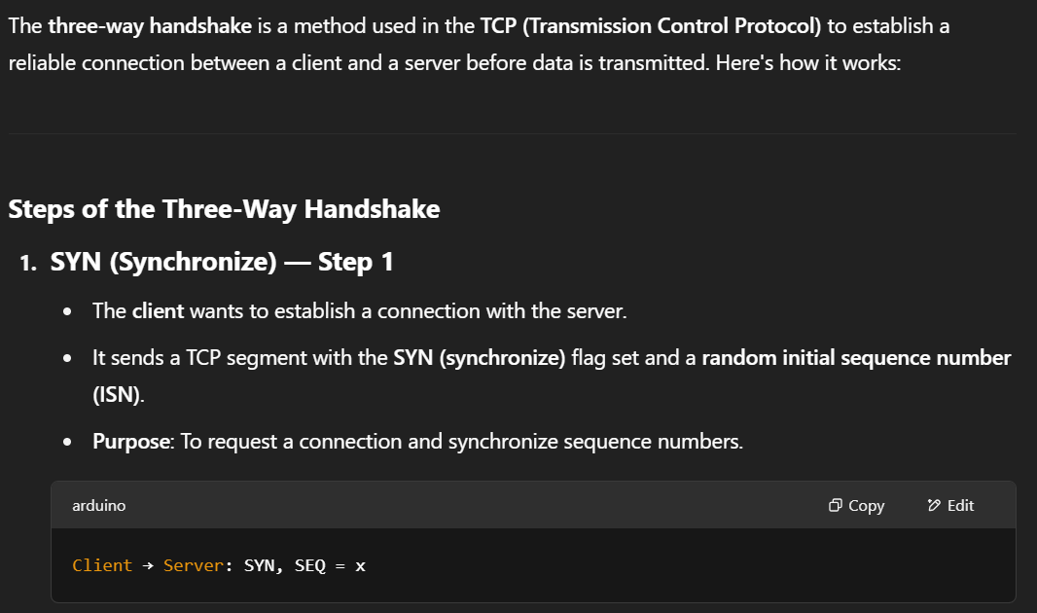

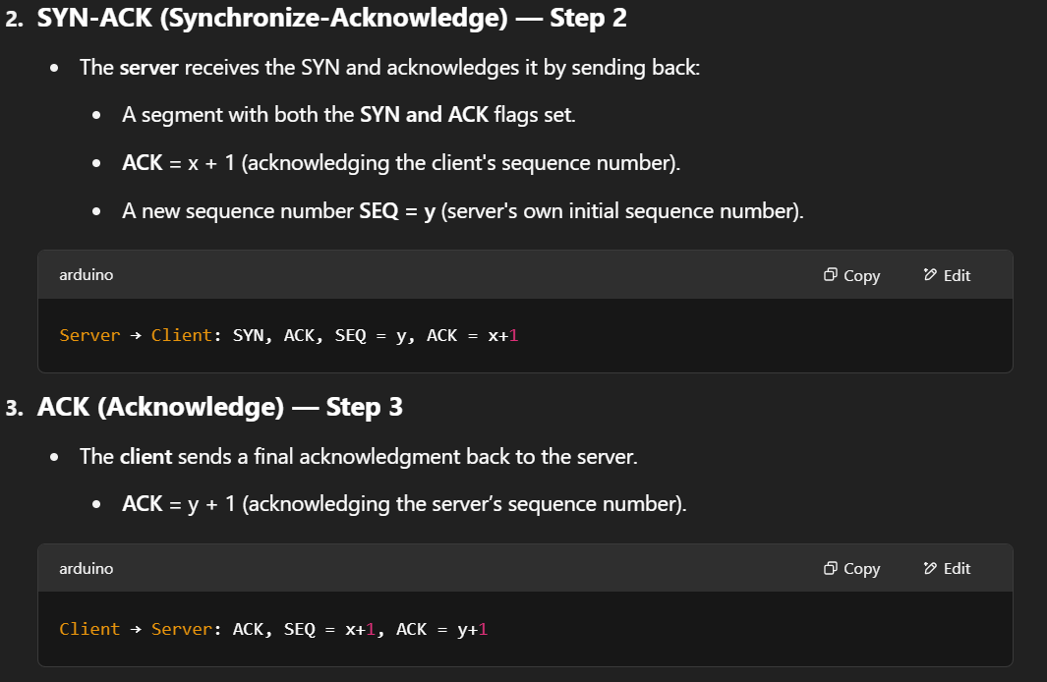

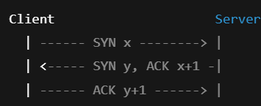

**Get Request VS Post Request**

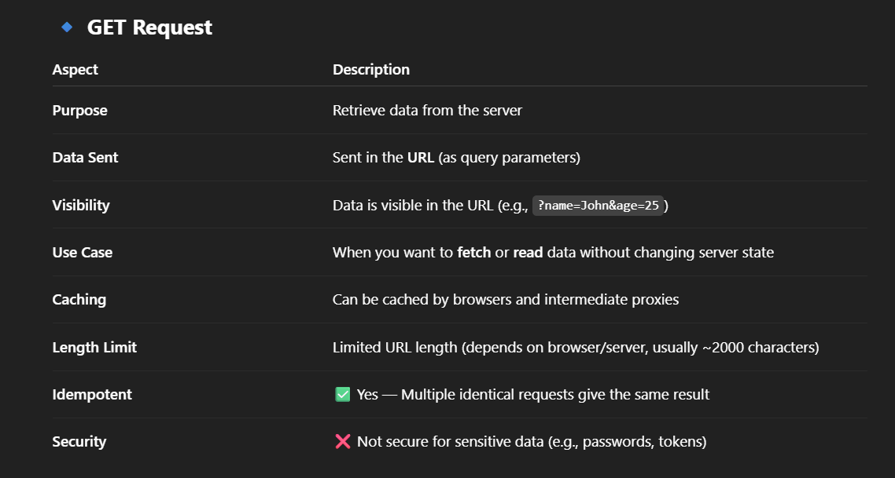

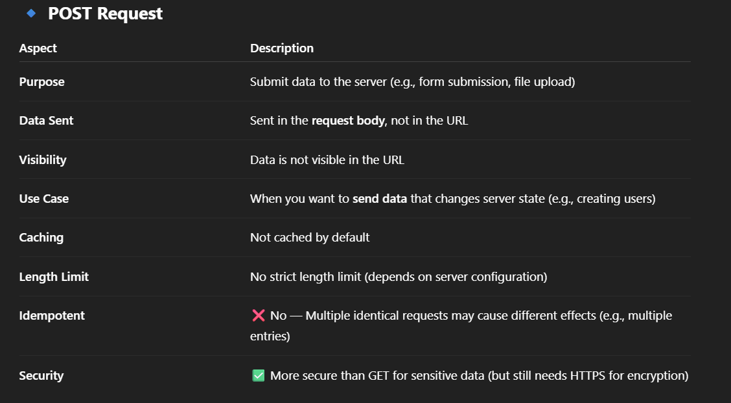

**Path Vector Routing**

